Chapter 5

Covalent network substances are those that are made from only ________-_________________ elements and contain ______________________ bonding, but do not form ____________________. These mostly contain _______ and _______ because these have _______ valence electrons. However it is important to remember that both carbon and silicon can still form covalent molecular compounds as well.

Covalent network compounds include ____________________, _____________________, ____________________________________ and _______________________________________. Other elements are capable of forming covalent network structures and these include things such as ___________________________________________________________________________.

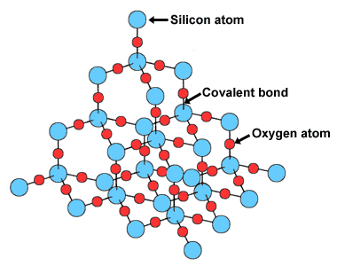
These compounds have the same type of covalent bonding as covalent molecular substances i.e. shared electrons localised between the nuclei of adjacent atoms. However this bonding extends throughout the network structure of the molecule and is not confined to discrete molecules. The ____________________ ___________________ _____________________ gives covalent network substances their special properties.

Very high melting and boiling point
Due to the ______________ _______ ___________________ structure which consists of strong covalent bonds _______________________, a large amount of _______________ is required to disrupt this bonding and therefore these substances have ___________ _____________ melting and boiling points.

Non-conductors of electricity
Covalent network substances do not contain mobile charge as there are no _________ and their electrons are highly ____________________. Therefore there is nothing that can carry a current. The one exception to this is ___________________.

Hard and brittle
Once again, due to the rigid 3D network structure and strong covalent bonding extending throughout the lattice, these substances are extremely hard. If put under enough _________________ or _____________________ the covalent network structure cannot distort without breaking ______________ covalent bonds _____ ______________. This causes the crystal to ____________________.

Chemically inert (relatively)
Due to the strength and structure of the extensive 3D network, these substances are reasonably _____________________ to ___________________ ________________. Thus they are generally unreactive substances.

Insoluble in water and most other solvents
Once again, due to the strength and structure of the extensive 3D network, it is difficult to ________________ this down which is what needs to happen for the substance to ____________________. Therefore most are insoluble in all solvents.

Allotropes of Carbon
Allotropes are substances that have the same ___________________ but different ____________________.

Diamond
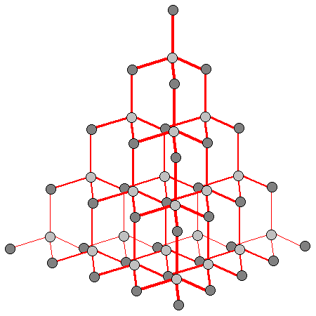
Each carbon atom in diamond is bonded to ________ other carbon atoms forming a continuous ___________________________ ______ _________________ structure where all bond angles are __________. Diamond exhibits all of the typical properties of a covalent network substance. It has a ____________ melting point, it is ____________, it is ______________ it does not __________________ electricity. It is the hardest known naturally occurring substance and also has the highest refractive index of any naturally occurring substance. This makes it an attractive gemstone for use in _______________________ as well as a useful substance to coat cutting instruments such as _________________, ____________, ______________ __________ and other _______________________ _______________.
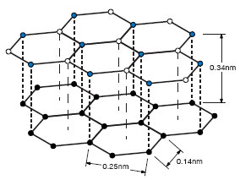
Graphite
Each carbon atom in graphite is bonded to _______ other carbon atoms forming a ___________________________ _______ ___________________. The fourth valence electron of each carbon atom is delocalised in between the 2D layers. This leads to some different properties than many network substances. Like diamond, graphite has a _____________ melting point, however it can ______________________ ___________________________ due to the delocalised layers of electrons and it is _____________ due to the weak forces of attraction between the layers. This is what enables the graphite in your pencil to slide off onto your paper – the delocalised electron layer means the layers of carbon are able to slide over one another quite easily. The chemical inactivity and electrical conductivity of graphite make it useful in different types of ____________________ and ____________.

Amorphous carbon
When the distance between the layers of graphite become _______________ this forms _____________________ ________________. Examples of amorphous carbon are _____________, ______________________, ______________ and ________________________ ________________. These substances can be used as a ___________________ in paints and inks, in photocopier _________________ and in car _________________. Activated carbon has been treated with __________________ to open up millions of _____________ on the surface, making the carbon able to ___________________ particular substances onto its surface. This can be used for ________________ ___________________, _______________________________ etc.

Carbon fibre
Carbon fibre is a form of graphite where the layers are thought to be ____________________ making it very ________________, _________________ and still __________________________. This makes it useful for golf clubs, bike frames, replacement joints etc.

Fullerenes
Fullerenes are allotropes of carbon that can be formed into ___________________ or _______________________ shapes. Their properties vary greatly based on their structure. __________________________ are a __________ molecule shaped similar to a soccer ball. ____________________________ can be extremely long, up to ______________________ atoms.

